Disciple making: sermon notes
discussion guide

based on Luke 5:1-11 (Linked to sermon of 09/01/22)
which can be accessed at www.stjamesbythepark.org/talks
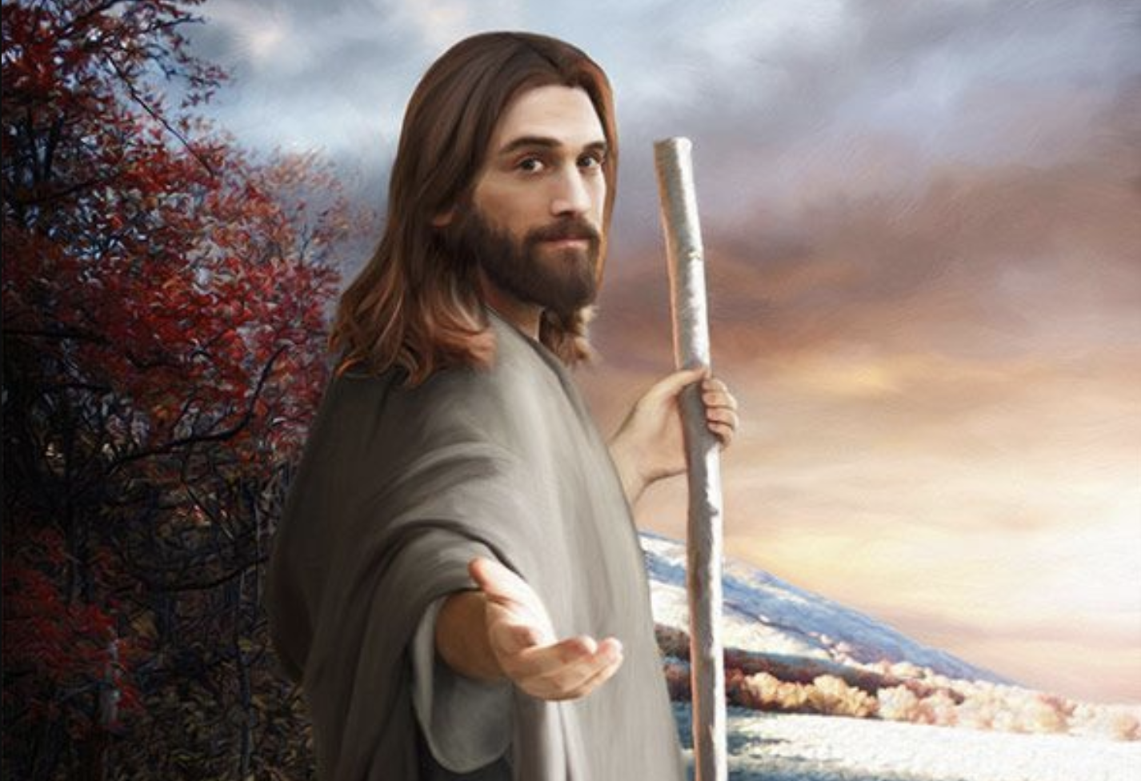

This was part of a series: Disciple making

Intro: This is really a continuation of our series on discipleship but we will be focussing our attention on disciple making, which is very much part of our calling as disciples of Jesus.

We will use three headings for the sermon notes: head (looking at the Scripture and beginning to understand what it means), heart (allowing God’s word to go deeper), hands (what are the practical out-workings of these Scriptures?) Feel free to begin each session with a time of worship. For each set of sermon notes I will suggest a psalm, Scripture or song you can use.

Worship: Use Psalm 138 or listen to “ What a beautiful name” https://youtu.be/r5L6QlAH3L4 and use this to begin your time together, expressing thanks and praise to God for his love and faithfulness.

Head:

Begin with a general discussion about disciple making. Does this daunt or excite people? How equipped do the group feel to share their faith with others?

Now read together Luke 5:1-11 and answer the following questions

- Where does this passage take place?
- Why does Jesus need a boat?
- Simon and his friends had been fishing all night. What was the result? How might they be feeling?
- How can we tell that the subsequent catch of fish was so miraculous?
- What is Simon’s response to the catch?
- In verse 5 Simon calls Jesus “Master” (a term of respect) but in verse 8 he calls him “Lord” (a term usually reserved for God). Why the change? What has happened to Simon’s perception of Jesus?
- What is Jesus’ response to Simon’s recognition of his sin and inadequacy in verse 10? How reassuring do you find this?
- In verse 11 what is the response of Simon and the others to Jesus’s call?
- How do you think you might respond in the same situation?

Heart:

Now read the passage again individually or together. Give some time for individual reflection and then share with one another, as you feel comfortable. You might like to imagine yourself as one of the crowd or as Simon Peter or James or John. What might you be feeling/thinking?

What particular verses or images resonate or leap out at you?

What might God be trying to say to you through these verses?

Does any part of the passage make you uncomfortable? If so, begin to ask God why and what he may be saying to you through this.

Hands:

Jesus calls these men to leave their profession of catching fish to a new one of catching people. How is Jesus challenging you to be a catcher of people? That might begin with praying regularly for non-believing family, friends and colleagues or asking God for opportunities to share faith with them. Talk honestly among the group about the challenges this represents.

In small groups:

Pray for courage and boldness for one another as well as lifting up to God those you would like to see come to know Jesus for themselves.

Come back together and pray the Grace:

May the grace of our Lord Jesus Christ, and the love of God and the fellowship of the Holy Spirit be with us all, now and forever. Amen.

