At our Annual Parish Church Meeting on April 3rd, we need to elect 3 people to our Church Council to serve a 3 year term. Could God be calling you to this important role? Who could you be encouraging to serve in this way?

Why is the Parish Church Council important?
The PCC is responsible (with the vicar) for “promoting the whole mission of the church: pastoral, evangelistic, social and ecumenical”. In practise, the PCC is responsible for discerning the vision and direction for St. James’ by the Park, and making major decisions to help bring that vision to fruition.

The PCC is the legal governing body of a Church of England parish. As such, it also has various legal duties with regard to our buildings, finances, paid staff and safeguarding procedures. However, we don’t expect PCC members to be an expert in any or all of these areas!

Who gets to be on the Parish Church Council?
The PCC is made up of:
* the clergy
* the elected church wardens
* 9 other elected members of the congregation – three of whom are up for election this April
* a few ‘deanery synod reps’ (who represent us to other Anglican churches in Southampton)
* some church staff also attend PCC meetings
* a Treasurer is also appointed by the PCC
* a youth rep is also co-opted by the PCC

What sort of people should stand for election to PCC?
Faith and character
None of us are perfect, but a PCC member should be able to say, “Follow me, as I follow Christ” – in other words, they should seek to be living a godly life, setting an example to others. The Bible says that a leader “must be worthy of respect, sincere” etc, and demonstrate integrity of belief, which means “they must keep hold of the deep truths of the faith with a clear conscience.”

Vision and leadership
We need people who can grapple with big issues and help make tough choices, helping us continue to discern God’s vision for our church, and the strategic priorities we need to move us forward.

Gifts and experience
None of us have all the gifts needed to lead a church, which is why the New Testament speaks of teams of leaders. We need a variety of gifts to make a rounded PCC. We need people who are willing to challenge our thinking, to contribute to discussions, preferably from a variety of backgrounds (age, gender, class, nationality etc).

Attitude
All of us have personal preferences for how a church should run, but PCC members need to put those aside to discern the corporate responsibilities the Lord is calling us to have as a community at this point in time. Christian leadership is about service.

Legalities
Candidates for election must be 16 or over and (unless under 18 at the election) have had their names on the Electoral Roll since Autumn 2016. PCC members are considered ‘trustees’ by the Charity Commission, meaning that some criminal convictions bar people from holding this office.

What sort of things will the PCC be discussing?
Our church vision is that God is calling us to turn our church community inside out. We want to enhance our ‘attractional’ mission, develop our ‘engaged’ mission and pioneer some ‘emerging’ mission (see our vision update paper from Autumn 2016). As well as developing our ‘Out’ mission, we need to keep working at our relationship with God (‘Up’) and each other (‘in’). Our investigations into a potential building development are ongoing. We also want to play our part within the bigger diocesan strategy (all the Anglican churches in the diocese of Winchester).

What is expected of a PCC member?
The PCC normally meet one Monday evening a month. Once or twice a year, we have a Saturday day-time meeting instead. Members are expected to prayerfully read through any papers related to the agenda before each meeting, and to contribute constructively to the discussion and decision-making process. Some PCC members also serve on various task groups (eg overseeing our external mission partners, or working on communications). Some also act as a ‘PCC link’ to individuals on the church staff team.

What next?
If you feel the Lord is prompting you to stand, speak with existing PCC members or the church wardens or clergy to gain more understanding of the role. Ask others whether they would be willing to propose or second you. If you can think of someone else who would be a good PCC member, approach them, or suggest them to the wardens or Dan.

Key dates
Completed nomination forms should be returned to the church office by Weds 29th March. The elections will take place at our Annual Parish Church Meeting on Mon 3rd April (you don’t need to be present to stand). The first meeting of the new PCC will be on Mon 24th April, followed by Mon 8th May, Mon 12th June, Mon 10th July. We expect PCC members to be present at most of the meetings.

Nomination form for election to the PCC of St. James’ by the Park, APCM 2017
I wish to put my name forward for election to
Candidates should also complete their personal declaration overleaf
The Parochial Church Council (PCC) of Shirley

Name of Candidate
(Block Capitals)
I confirm that I am over 16, and, unless under 18 on 3rd April, I have been on the Electoral Roll of the PCC of Shirley since before October 2016 (please tick)
No person shall be nominated unless they have signified their consent to serve, or there is in the opinion of the meeting sufficient evidence thereof. No person shall be nominated if they are disqualified from serving by the bishop under section 10(6) of the Incumbents (Vacation of Benefices) Measures 1977 and 1993, or if they are disqualified from being a charity trustee under the Charities Act 2011.
Note: A person is disqualified from being a charity trustee under the Charities Act if they have been convicted of an offence involving deception or dishonesty (unless any such conviction is legally regarded as spent), if they are an undischarged bankrupt, have made compositions or arrangements with any creditors from which they have not been discharged or have been removed from serving as a charity trustee, or been stopped from acting in a management position within a charity.
Signature of Candidate
(indicates willingness to stand)
NB - All proposers and seconders must be on the Christ Church Electoral Roll

Proposer (Block Capitals)
Signature of Proposer

Seconder (Block Capitals)
Signature of Seconder
Candidates should also complete their personal declaration overleaf
Personal Declaration
We would like you to write or email a maximum of 150 words outlining your response to the question below which will be circulated for members of the Church to read and pray through. Please use the space below for your response and also email the church office with an electronic version and a recent photograph.
Why do you feel led to stand for election and what would you bring to the PCC?

(You can e-mail this response to theresa@shirleyparishchurch.org)

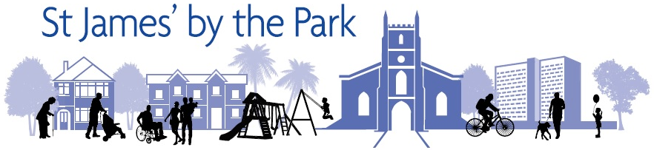

Elections for the Parish Church Council (PCC) of St. James’ by the Park

Is God calling you or someone you know to play a leadership role within our church?

