SHAPE: Discovering and Developing our spiritual gifts

You may find this teaching material quite a lot for one session so feel free to use it over two sessions. I will add additional resources you can use as well.

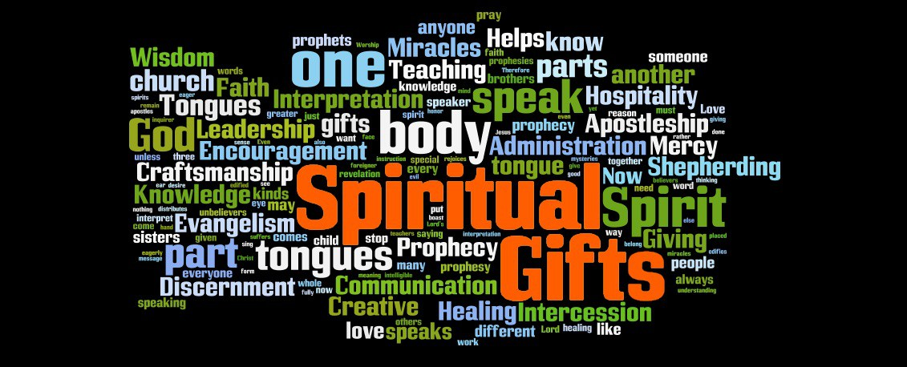

Over the next few months our Sunday morning teaching will focus on spiritual gifts: What are they? What are they for? How do we use them? How do we grow them?
We will be looking at them in the context of SHAPE:
Spiritual Gifts
Heart
Abilities
Personality
Experiences

Together all five of these will impact the way God uses us both within and outside of the church, how we connect with God and each other and how we discover more about what God has called us to. In this study we will look at the Biblical texts on the spiritual gifts, we’ll begin to think about what spiritual gifts we see in ourselves and others and then think about how God might want to use them. Let’s start with worship.

Worship: either read Psalm 84 or listen to/sing along to “Here I am to worship” https://youtu.be/03G52K9X2hQ Then spend some time thanking God for the gift of the Holy Spirit and His presence in us.

Bible base

Jesus promised to send the Holy Spirit after he rose from the dead. Read John 14:16-17, 25-26. What do we find out about the Holy Spirit here?

At Pentecost the disciples were filled with the Holy Spirit. Read Acts 2:1-4,17-18 What spiritual gifts are evident or mentioned? (Don’t forget the transformation of Peter himself!)

Paul gives us several lists in his letters of the spiritual gifts. Have a look a these scriptures and make a list of the gifts mentioned (to save time, you may want to divide this up for different people or pairs to do and then collate a list together):

Romans 12:3-8
1 Corinthians 12:1-11, 27-31
Ephesians 4:11-12

Discuss the following questions and anything else that springs to mind from reading these passages:

- Are there any gifts you think are missing from these lists? If so, what are they and why do you think they are missing?
- Are there any gifts that you are surprised to find on Paul’s lists? If so, why?
- Do you recognise any of the gifts in:
- Other people in your church
- Other people in your group
- Yourself
(Take your time over this. You may need to stop to pray and reflect. You may even want to come back to this in the next session. We will be revisiting gifting in the final session as well.)
4. What do you think the spiritual gifts are for?
5. How can we use our spiritual gifts, in church and outside of church (you might like to choose 3 or 4 gifts and think about how they might be used to bless and build up others)
6. Paul tells us to “seek earnestly the spiritual gifts” 1 Corinthians 14:1 How do you think we can do this?
7. To what extent do you think spiritual gifts can be given for a season? Are there spiritual gifts you have had in the past which seem to be dormant now?

Growing in gifting

Your group is probably made up of people with widely different experiences of the Holy Spirit and spiritual gifts. Make time to discuss past experiences, present concerns or indeed encouragements.

Finally pray together, either in small groups or as a whole. Ask God to give you insight into the gifts He has given you and, as you feel led, tell others what gifts you see in them. My experience is that we often can’t see God’s gifts in ourselves but you see them more clearly in others.

Encourage one another to seek God for His gifts and how you can use them to build others up.
“Like good stewards of the manifold grace of God, serve one another with whatever gift each of you has received” 1 Peter 4:10

Additional material:

Some explanations of the spiritual gifts can be found on the church website http://www.stjamesbythepark.org/shape

There is a free online test which you can do if you want to find out more about your gifts https://www.freeshapetest.com/

There are also some helpful teaching on the spiritual gifts on youtube. I recommend this one as it is fairly short but powerful. He focuses on the nine gifts but of course, scripture talks about many more. https://youtu.be/xZNagnAxM4A

