SHAPE: Heart. What is your passion?

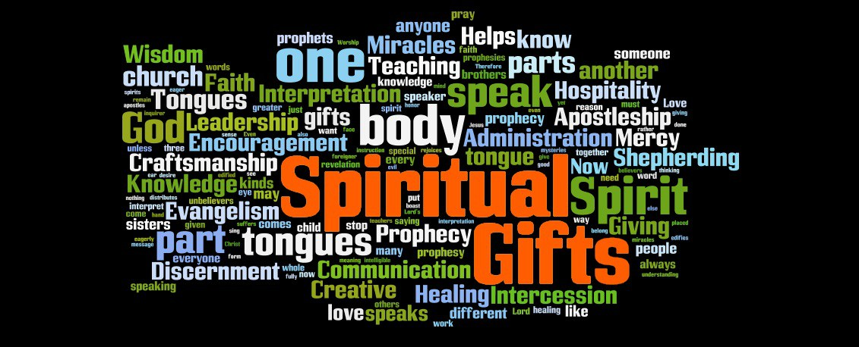

We’re going to be looking at the second letter of the SHAPE acronym, heart. When we are passionate about something or someone, it often doesn’t feel like hard work and can be incredibly fulfilling. As we seek to discover God’s calling in our lives, it's important to look at the things that bring us joy and satisfaction. These are often God given desires and can be helpful in discerning what God is calling us to.

Worship:

Either read Ps 37:1-7 or listen to https://youtu.be/mZGzu6oI9b4 I Give You My Heart. Spend some time thanking God for His grace and asking Him to give you open hearts to hear His word to you.

Bible base:

Look again at Ps 37:1-7 and discuss the following:
- How do you think trusting in God is linked to security/safety?
- How does the psalmist suggest we might gain the desires of our hearts?
- What do you think delighting in the Lord looks like in practical terms?
- How do you think committing our way to the Lord is linked to our heart’s desires?

Now read 2 Chronicles 1: 7-12 and discuss the following questions:

- What would you ask for if God asked you that same question in verse 7?
- What does Solomon ask for and why?
- What does God give him?
- What does this passage tell us about desire and motivation?

How do we assess our heart’s desires?

When we talk about our heart in this context, we are really thinking about our desires and passions, the things that drive and motivate us. We talk about someone’s heart being in something (or conversely not being in it) by which we mean that someone has a passion for what they are doing. When we do things we are passionate about, we are committed to them and want to see them through.

Spend some time thinking about and discussing what you are passionate about. Give each group member a piece of paper, then get them to fold the paper into four. In each quarter write the following titles: PEOPLE, CAUSES, SERVICE, NEED. Give about 10 minutes for each person to prayerfully fill these in for themselves by answering these questions:

PEOPLE: Which people or groups of people do you feel passionate about (e.g youth, older people, disadvantaged, disabled etc)?

CAUSES: What causes are you passionate about? (these could be charities, political groups, environmental issues or local issues)

SERVICE: How do you love to serve others? (e.g. through hospitality, encouragement, prayer, friendship etc.)

NEED: What needs tug at your heart and move you? (e.g.poverty, mental health, loneliness)

Give some time to discussing in pairs or as a group what you have written down.

Prayer: Spend some time praying for one another in pairs or as a whole group that God would begin to bring clarity to one another as to how we can follow our God given desires and what steps God might want us to take next.

