Making disciples, who’s invited?: sermon notes
discussion guide

based on Luke 5:27-32 (Linked to sermon of 06/02/22)
which can be accessed at www.stjamesbythepark.org/talks
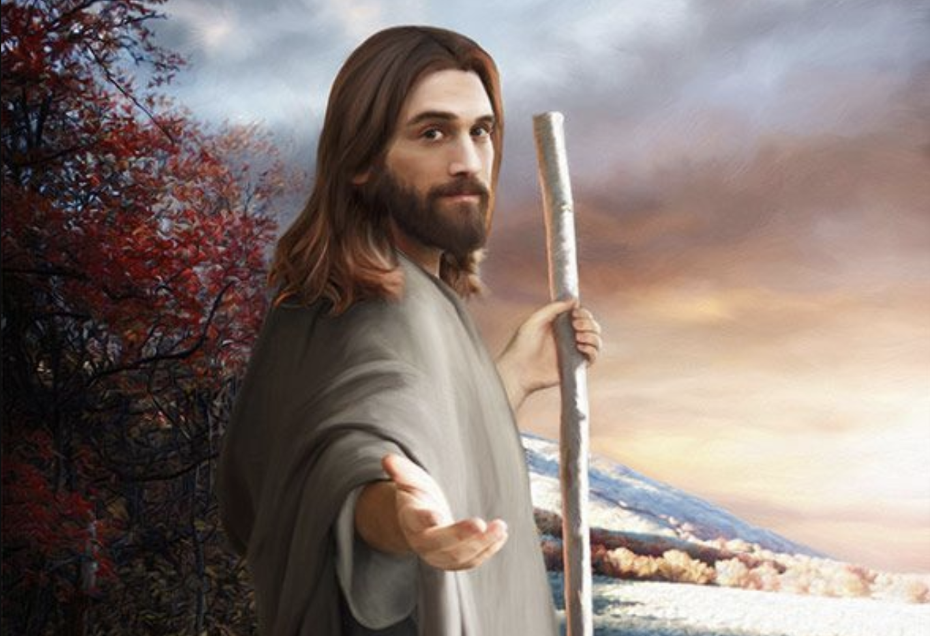

Worship: Either use Psalm 105:1-6 or https://youtu.be/weWAIe68Gk8 “How great is our God” to begin a time of thanking God for His provision and love.

Starter: Think of the name of one person who has made an important impact on your spiritual journey. Share who and why with the group.

Head:

Read the passage through and discuss the following questions, as well as anything else that strikes you about the passage (you might like to also look at the other accounts in the gospels of this event - Matthew 9:9-13 and Mark 2:13-17. Note that Matthew is his Greek name, Levi the Hebrew one). For more information on the role of tax collectors see https://www.biblegateway.com/resources/encyclopedia-of-the-bible/Tax-Collector ;

- What is Levi’s profession and why would people be surprised at Jesus approaching him?
(you might like to look at the following scriptures in addition to help: Luke 3:12 and Luke 18:9-14)

- What would be a contemporary version of a tax collector?
- What does Levi do when Jesus calls him? What would that mean for him in practical terms?
- What does Levi do next and why do you think he does it?
- What sort of people were invited to the banquet?
- Who is not happy and why?
- What is Jesus’ reply?

Heart: Here are a few discussion points. Feel free to cover some or all of them.

- Imagine that you have just had some great news and want to share it with friends by throwing a small party. Who would you invite? Would they all be Christians or a mixture? Now read Luke 14:12-14.

- Imagine Levi’s first meeting with the other disciples. How do you think that went? What would Peter and the other fisherman have made of having someone who worked for the Romans as a fellow disciple? How might we learn from Jesus’ choice of disciples?

- When Jesus answers your prayers or blesses you, do you ever share that with non-believers? If not, why do you think that is? How difficult/easy do you find sharing your spiritual journey with non-believing friends? Read 1 Peter 3:13-16.

Hands:

On Sunday Dan challenged us to think about whether we only surround ourselves with Christian like ourselves or whether we have friendships outside church. Think about those friendships you have and, in small groups, pray for these people that they may come to know Jesus for themselves and know the joy of salvation. Then pray for one another.

