SHAPE: Personality

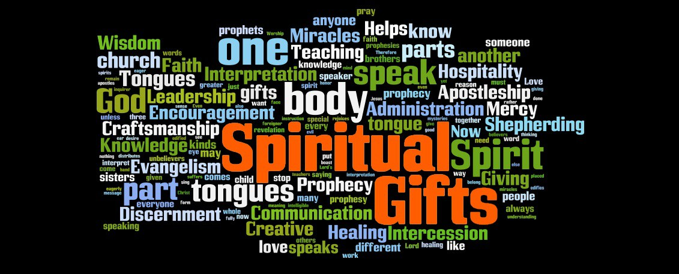

God has created each of us as individuals, with different personality traits. These need to be recognised and celebrated if we are to function well as the body of Christ. In this session we will be exploring our personality and how that affects the way we interact with others and how we minister.

Worship:

Read Psalm 139 or listen to https://youtu.be/BGPmMcDeRpM Create in me a clean heart. Spend some time in prayer, asking God to reveal more of Himself and give you understanding of how He has created each of you to be. Thank God for each other.

Bible:
Read through Psalm 139 again and discuss the following

- Which verses speak most powerfully to you and why?
- How in this psalm do we get a sense of God’s omnipresence (present everywhere)?
- How in the psalm do we get a sense of God’s omniscience (all-knowing)?
- How in this psalm do we get a sense of God’s omnipotence (all-powerful)?
- What encourages you in this psalm and why?
- What disturbs you in this psalm and why?
- Can you echo David’s sentiments in verse 14 or do you find that difficult?
- In verse 23 David asks God to search his heart. How do you feel about echoing that prayer?

This psalm speaks powerfully of God’s intimate knowledge of us and our inner thoughts and motivations. It is wonderful to think that the God who knows us better than we know ourselves also loves us more than we can ever know!
Activity

On the website are various activities you can look at individually to help you explore and identify your personality traits. It is worth saying that none of them can be completely accurate and are just a guide. Also we change over time and through circumstances, so you might find, even if you have done personality tests in the past, that the outcome has changed. For those meeting in a group, I hope the following will be a fun and different way of exploring who you are and how you are perceived by others.

Write the names of everyone in the group on separate pieces of paper. Fold them and put them in a bowl. Each person in the group selects a piece of paper. If they get themselves, they will need to put it back and choose again! Don’t reveal who you have got! Using the name on the paper, write down 3 adjectives that you would use to describe that person. Once everyone has done this, in turn, read out the three adjectives and see if others in the group can guess who you are describing.

Fold the names again and replace them in the bowl. Select one name again and don’t tell anyone who you have. This time, describe the person on the paper in the following three ways: as an animal, as a Biblical character, as a food. See if others can guess who you are describing this time.

Depending on time, you can add other elements, e.g. if this person were a car/plant/book etc.

Discussion

Hopefully that was a bit of fun but also revealing.
How did people feel about the way they were described?
Were there any surprises?
How does your personality affect your ministry in the Body of Christ? (If you are an introvert you may not want to be upfront and if you are an extrovert you might struggle to do things alone)
Does your personality ever get in the way of what you feel God is calling you too?

Prayer:

Spend some time praying for one another, specifically thanking God for the differences that you have as well as the similarities.

“May the God of steadfastness and encouragement grant you to live in harmony with one another in accordance with Christ Jesus, so that together you may with one voice glorify the God and Father of our Lord Jesus Christ.” Romans 15:5-6.

