Hope for the Hurting: guilt
discussion guide
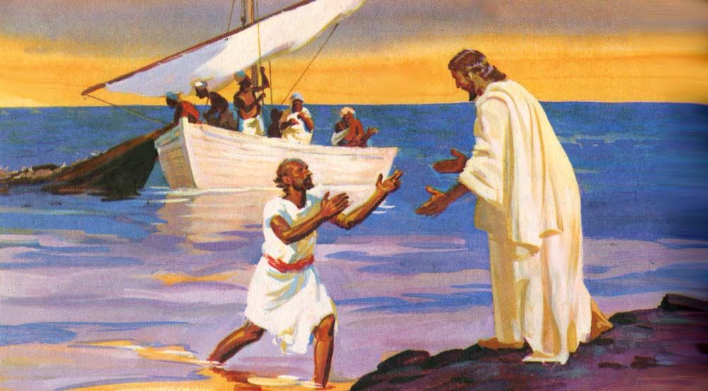
based on John 21:15-19 (Linked to sermon of 25/04/21)
which can be accessed at www.stjamesbythepark.org/talks

This was part of a series: Hope for the Hurting

Intro: I’m sure we have all experienced the awful sense of having let Jesus down, just as Peter had but how wonderful that just as Jesus did with Peter, he longs to restore us to full communion with him, although the process can sometimes be quite painful.

How does this passage speak to our desire to be a God-dependent, grace-filled, Bible-based, mission-focused, authentic community?

Up (Go deeper with God):

Begin with a short time of confession – you could use one of the prayers of confession from the Church of England https://www.churchofengland.org/prayer-and-worship/worship-texts-and-resources/common-worship/daily-prayer/forms-penitence
Or read Psalm 51:1-12. Then praise God for his forgiveness through prayer and/or song https://youtu.be/UoGZsWsclRk We are forgiven.

Read the passage through a few times together. Spend a bit of time trying to imagine the scene:

- Do you think Jesus took Peter to one side or were the rest of the disciples listening in? (Verse 15 may suggest the later) What difference does it make?
- Why do you think Jesus asks Peter whether he loves him “more than these”? (this could refer either to the disciples or the fishing – the Greek is unclear). Look at Mark 14:29 – does this make a difference to your answer
- How many times does Jesus ask Peter if he loves him? Why is this significant? (see Mark 14:66-72 if you’re not sure)
There are two different Greek words used for love in this passage. The first two times Jesus askes Peter if he loves him he uses the verb “agapao” which refers to the highest form of sacrificial love. The final time Jesus asks Peter using the verb “phileo”, which is also the word Peter has used in his replies to Jesus (this sort of love is used for friendship and affection).
- What is significant in the choice of words used?
- Why do you think Peter feels unable to reply to Jesus using the verb agapao?

After each of Jesus’ questions, he commands Peter to do something
- What does Jesus tell Peter to do?
- How do you think the commands of Jesus and connected to his questions?
- What has Peter been commissioned to do? (look at Matthew 16:13-20, 1 Peter 5:1-4)
- How do you think Peter’s understanding of his calling might have changed as a result of his denial of Jesus and subsequent restoration?

In (Grow closer to each other):

When we fall short and let God and others down we tend to react in a variety of ways. Some of us hide away from God and others (just as Adam and Eve hid from God), some of us try to minimise the wrongdoing, either by blaming others or becoming defensive. Be honest with each other, when you have done something wrong, what is your usual reaction?
In this passage, Jesus gives Peter a rather public opportunity to be restored to fellowship with him and to be restored to his calling as an apostle. James 5:16 encourages us to “confess your sins to one another and pray for one another”.

How comfortable do you feel confessing your sins to others?
What might hold you back?
How do you think we can create a more open and honest culture within or small groups and church?

If it feels appropriate, split into small groups to pray for one another.

Out (Reach further with the good news):

Guilt is not only an issue for Christians. Many unbelievers suffer from long held guilt or unforgiveness, often to the detriment of their mental and physical health. Spend some time lifting friends, neighbours and colleagues who you know need to experience Christ’s forgiveness and restoration.

