SHAPE: Experiences

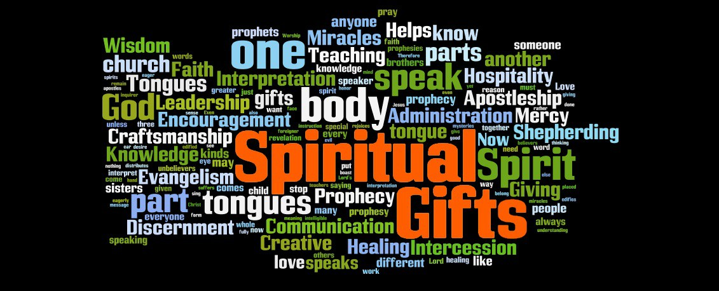

We are all shaped by our experiences in life. Most of these were beyond our control. But God allowed them for the purpose of moulding us. Nothing is wasted. Joseph is an example in the Bible of how God used his past experiences, often pretty negative ones, in the world’s eyes, to prepare him for leadership and ministry. You can probably think of other Biblical figures for whom the same is true. It is true for us too. Whatever we have gone through, good and bad, God can use.

Worship: Begin by reading 2 Samuel 22:1-20 or listen to https://youtu.be/DpuUlPfx0Ow - Surrounded. Praise God for His love and protection.

Bible:

Have a look at the life of Joseph in the Bible. It is too much to read in one session so here is a summary. In Genesis 37 Joseph is hated by his brothers as he is his father’s favourite and sold into slavery. In chapter 39 Joseph is falsely accused of adultery and thrown into jail. In chapter 40 in jail Joseph interprets other prisoners’ dreams but is forgotten about when they are freed. In chapter 41 Joseph is remembered and interprets the pharaoh's dream and is promoted to second in command of Egypt.

Read Genesis 41:46-49, 53-57 and Genesis 50:16-21 and then discuss the following:

- How do you think Joseph’s experience at the hands of his brothers equip him in later life?
- Joseph experienced a number of injustices in his life. How might that have affected him, for good or bad?
- How does Joseph use the power he is given?
- How is reconciliation achieved with his family?
- What surprises you about the story of Joseph?
- What disturbs you about the story of Joseph?
- What do you think we can learn from the story of Joseph?
Activity

Speaking in a group about past experiences may be hard for some. Be sensitive to one another and share only what you feel comfortable with. You may want to explore these questions more deeply alone or with your prayer partner or close friend. We are going to look at six areas of experience. You may not get through them all and you may want to split into smaller groups for ease of discussion.

Examine these experiences from your past:

- Family experiences: Are there particular experiences that stand out to you? How have they shaped your view of God or of other people?

- Educational experiences: What were your favourite subjects at school? What are standout memories of school, either good or bad? How have the choices you made at school influenced your life?

- Vocational experiences: What jobs have you been most effective in and enjoyed most?

- Spiritual experiences: What have been your most meaningful times with God? When have you felt God spoke most clearly to you? When have you felt most close to God?

- Ministry experiences: How have you served God in the past? When have you felt most fulfilled in ministry?

- Painful experiences: What problems, hurts, thorns, and trials have you learned from?

Prayer

For some people in the group, thinking about past experiences may be quite painful. It would be good to cover one another in prayer, asking God to protect hearts and minds.
End by reading Romans 8:31-39 to remind you that nothing can separate you from God’s love.

