SHAPE: Summing up session

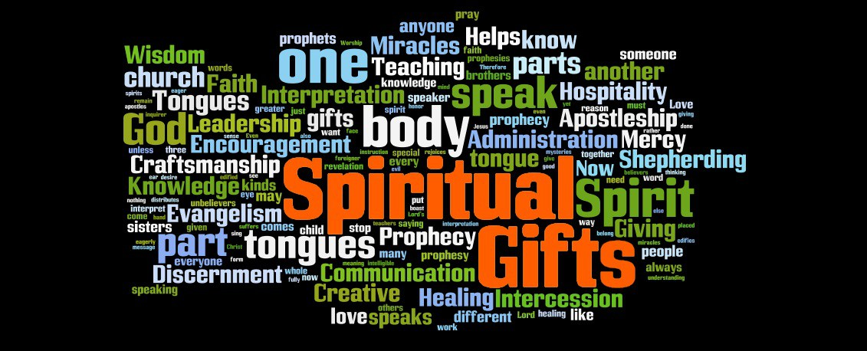

I hope you have found this a useful course. Our prayers are that God will use this to enable and empower you to move in your ministry with more clarity and dependence on the Holy Spirit, that you will have gained a better understanding of yourself and your gifts and abilities and that as a church, we may grow “into a holy temple in the Lord” Ephesians 2:21.

Worship:

Read Psalm 63 and Listen to 10,000 reasons https://youtu.be/DXDGE_lRI0E then spend some time praising God for who He is, His personality, gifts, abilities and experience, for it is He who bestows all of these on us as well.

Bible:
(as a leader you might bring some stones along as illustration. Try to find ones of various sizes and shapes)
Read 1 Peter 2:4-10 and discuss the following questions
- What analogy does Peter use for us as Christian in verse 4? How do these pictures help in understanding how we fit together as a church?
- How does God see you in verse 4? How does that feel?
- Who is building the house of living stones?
- How else are we described in these verses (v.5, 9,10)? How do these different descriptions add to your image of you as a believer?
- How can we tell that this house is well built and has strong foundations? (v.5, 6,7)

Activity:

Use the profile below to help you sum up some of what you have learned about yourself over the course of these sessions. You may not be able to fill in all the sections but do what you can and return to it from time to time as you gain more insights. Feel free to ask others in the group for input.

SHAPE profile:

Spiritual Gifts:
My top five Spiritual Gifts are:
1. ....................................................................................
2. ....................................................................................
3. ....................................................................................
4. ....................................................................................
5. ....................................................................................

Heart:
The thing that really drives me is...
...........................................................................................................................................................................
...........................................................................................................................................................................
...........................................................................................................................................................................
The people I really care about are...
...........................................................................................................................................................................
...........................................................................................................................................................................
I want to help these people meet the following needs...
...........................................................................................................................................................................
...........................................................................................................................................................................
...........................................................................................................................................................................
The cause I will help conquer is...
...........................................................................................................................................................................
The dreams I will do my best to fulfil are...
...........................................................................................................................................................................
...........................................................................................................................................................................
...........................................................................................................................................................................

Abilities:
My top five Abilities are:
1. ....................................................................................
2. ....................................................................................
3. ....................................................................................
4. ....................................................................................
5. ....................................................................................

Personality:
I would describe my personality as...
...........................................................................................................................................................................
...........................................................................................................................................................................
...........................................................................................................................................................................
.......................................................................................................................................

Experience:
The lessons I have learned from my positive and painful experiences include...
...........................................................................................................................................................................
...........................................................................................................................................................................
...........................................................................................................................................................................
Out of all my experiences, good and bad, which ones do I believe will help me most in serving and ministering to others ... and in what way?
...........................................................................................................................................................................
...........................................................................................................................................................................

Prayers

Each pick one of the stones which most appeals to you. As you pray for one another, place your stones together on the floor or table as a reminder that you are being built together into a spiritual house of living stones.

“Like living stones, let yourselves be built into a spiritual house”

If as a result of this course, you want to discuss your sense of calling or gifting, feel free to contact Georgia (georgia@stjamesbythepark.org) or Dan Clark (dan@stjamesbythepark.org)

