God’s Strength in our weakness: God’s power in weakness
discussion guide
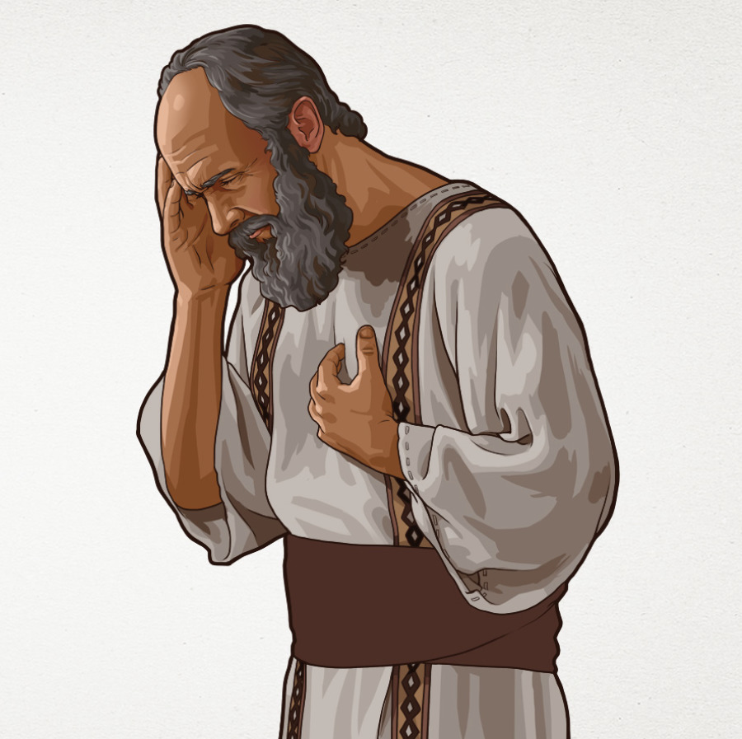
based on 2 Corinthians 12:1-10(Linked to sermon of 11/07/21)
which can be accessed at www.stjamesbythepark.org/talks

This was part of a series: God’s strength in weakness

Intro: I wonder what you imagine Paul’s thorn in the flesh was? Perhaps a physical disability, a mental health issue or a continuing problem in his life. We will never know this side of heaven but no matter what our issues are, Paul gives us hope that God can work powerfully through us even when and perhaps especially when we feel weak.

How does this passage speak to our desire to be a God-dependent, grace-filled, Bible-based, mission-focused, authentic community?

Up (Go deeper with God):

Either listen to “You are my strength” https://youtu.be/eeezo01meFA together or spend some time reading through and meditating on Isaiah 40:27-31. Then spend some time praising God for his strength and protection.

As leader, you might want to do a little background on the church at Corinth, which Paul founded in Acts 18, before diving into the passage. The church was riddled with issues of division in 1 Corinthians 3, sexual immorality in 1 Corinthians 5 and Christians taking one another to court in 1 Corinthians 6. Along come some impressive preachers, who wow the Corinthians with their talk of miracles and visions and they unfairly compare Paul to them. 2 Corinthians 12 is part of Paul’s defence, where he turns the idea of boasting on its head.

Read through 2 Corinthians 12:1-10, then discuss the following:

- What achievements are you proud of? Do you ever “boast of them”?
- British people tend to be quite self-deprecating, to what extent do you think boasting is okay?
- What do you find unusual about what Paul boasts about?
- How can we tell he is rather uncomfortable about talking about his visions?
- What do you think Paul’s thorn in the flesh might be? (Galatians 4:13 would suggest some sort of physical ailment)
- Who sends this thorn? ( worth looking at Job 1:6-12 as a comparison)
- Why does Paul think this thing was sent to him?
- Paul prays three times, which in Biblical speak means a lot, but God was clear that he was not going to answer the prayer. How does Paul see this as something to boast in?
- There are a lot of paradoxes in this passage. Which ones stand out for you most?

In (Grow closer to each other):

Either together or in smaller groups, discuss the following:

What are your “thorns in the flesh” or weaknesses (they could be physical, mental, external)? Are you able to boast in them?
To what extent do they hold you back from fully entering into all that God has for you?
How might you work toward getting to the point that Paul did where you are “content with weaknesses”?

Pray for one another into those weaknesses. It may be that unlike Paul’s God wants to remove them but it may be that we learn to lean on God’s strength in the midst of them.

Out (Reach further with the good news):

We live in a culture which defines us by our successes and achievements but that is not how God’s kingdom operates. If you have a look at The Beatitudes in Matthew 5:1-12 you can see that we are part of a topsy turvy kingdom. How can we try to live out these contrary values in our own neighbourhoods and workplaces? What might it look like if we were open about or weaknesses and failures?

Spend some time praying silently for transformation, openness and vulnerability to God to integrated into your daily life.

You might like to end by proclaiming together as a group Paul’s words:

“Therefore I am content with weaknesses, insults, hardships, persecutions and calamities for the sake of Christ; for whenever I am weak, then I am strong”

