Remaining an apprentice: sermon notes
discussion guide

based on John 15:1-15 (Linked to sermon of 24/10/21)
which can be accessed at www.stjamesbythepark.org/talks

This was part of a series: Being an apprentice

Begin your time together by reading Psalm 131 or listening to the sung version Sons of Korah - Psalm 131
Spend some time in silence, allowing the business of the day and its concerns to be lain at Jesus’ feet. Someone can pray to begin your study together, asking God to bring fresh insight and understanding of His word.

Head:
Read through John 15:1-15 together (you might like to read it through in several different translations) and then discuss some of the following questions:
- Which words seem to be repeated throughout the passage? Why do you think this is?
- If you were to sum up the passage in one phrase, what do you think Jesus’ main message to his disciples is?
- The word used for pruning in verse 2 actually means to cleanse (we get our word catharsis from it). Does that change your understanding of this verse or add to it?
- How do you feel about what happens to the unproductive branches?
- According to the passage, what do we need to do to bear fruit? (v.5, 7-8)
- How, according to the passage, do we “abide/remain in Christ”? (v.10)
- Verses 9-13 focus on love. What do you think it means to “abide in love”?
- Verse 9 links obedience to Jesus’ commands to love. Look at John 13:34 and Luke 6:27-36 and explore how you think obedience to Jesus and love might be connected.
Heart:
Either bring along some grapes and/or vine leaves or use the picture to reflect on the imagery of the vine:
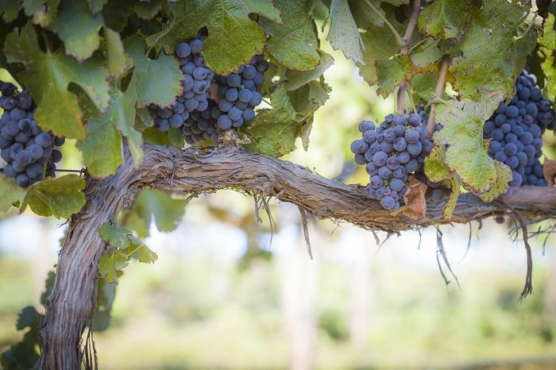
Spend a little time in quiet reflection, looking at the picture or at the vine leaves and grapes. If you have time, you might even like to read up on pruning vines to give you more insights, such as https://www.rhs.org.uk/fruit/grapes/pruning-training. Then ponder the following and share as you feel comfortable.
What sort of branch do you see yourself as at the moment?
One being pruned? A fruitful branch? A bare branch?
Sometimes it is difficult to see our own fruitfulness. While it is important for us to be honest before God about where we see ourselves on the vine, other Christian brothers and sisters may be able to see more objectively. Share where you feel you are but also allow time for others to share how they see you too.
Hands:
What steps can we take in our daily lives to more fully “abide in Christ”? Perhaps chose one or two practical steps you can, such as listening to Christian worship music while you drive or do routine tasks; praying as you walk to work or to the shops; asking Jesus’ blessing on those people you meet each day whom you find difficult to love.
Finally pray for each other, either in small groups or as a whole. You could end with this prayer:
Heavenly gardener, thank you for cleansing me and continuing to work on my life. Help me to remember that I can do nothing without you but everything in you. Help me to stay close to you and make me a fruit bearer.
In the name of Jesus, the Vine, Amen.

