SHAPE: Ability

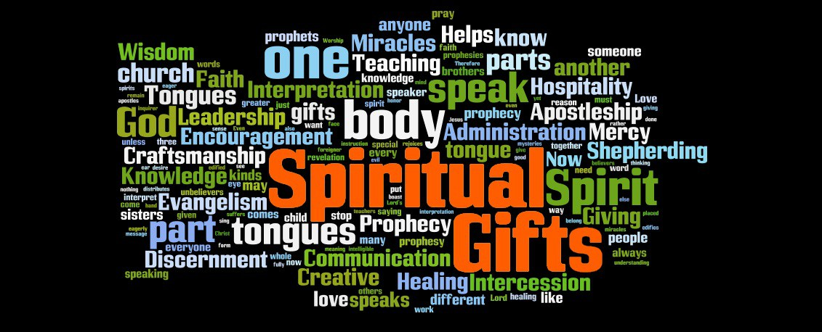

As we look at the SHAPE format, it is intended to look at us as a whole person, just as Christ does. God created each of us with different attributes, gifts, desires and abilities. We are all unique! As we look at this area, I’d encourage you to be honest and try not to compare yourself with others. There is always a temptation to compare ourselves unfavourably with others but God wants us to appreciate the abilities He has given us and use them for His glory.

Worship:

Begin by reading Isaiah 51:1-11 or listen to Creator God https://youtu.be/uI6gd4Or0lU Spend some time thanking God for His creation of the world and one another.

Word:

Read Matthew 25:14-30 The Parable of the talents and then discuss the following questions:

- What criteria is used for distributing the talents in verse 15? Why do you think the master does this?
- What do each of the three slaves do with their money?
- What is the master’s response to each of the slaves when he returns?
- How do you feel about the treatment of the final slave?
- What do you think the moral of this parable is?

The parable seems to encourage us to use what we have to bring fruitfulness. What abilities do we have that we can use to God’s glory? Colossians 3:17 says “And whatever you do, in word or deed, do everything in the name of the Lord Jesus, giving thanks to God the Father through Him”.
Let’s begin to think about our own abilities. As Christians and as Brits, we are not very good at talking about what we can do. We often think of it as boasting. Look at Romans 12:3. We are not to boast but we are to recognise our gifts. Recognising our abilities as God given gifts can help us to see that God wants us to use them to benefit others and encourage. If you are not sure what your abilities are there is a long list of abilities on the website which you can print off to help, if you’d like, or you can try the following exercise:

- Write down 5 things that you are good at (they could be practical things like DIY, cooking, painting or more general things, such as good with figures, good at making friends, they may relate to a job you do or have done).
- Next to each ability, think about a way you could use it to benefit others and please God (for example, if you are good at cooking you might like to take a cake or meal to someone you know who doesn’t have the time or skill, if you are good with figures you might help someone with their tax form, if you are good at languages you might like to support a refugee in learning English).

Share these in the group. You may find they confirm your list and even add to it!

- Now write down some of the abilities you see in the other members of your group.

Share these with each other and begin to think how God might use these abilities in the church and your community.

Prayer

Spend some time praying for one another, thanking God for the abilities you see in one another and asking God to show you how you might use them best. It would be a lovely opportunity to begin to ask God for gifts of discernment and wisdom as well as pictures and words. Sometimes we worry about sharing them, if we are not certain they are from God. Your small group is hopefully a safe space to practise and if you’re not sure say so but share it anyway. God will make it clear to whoever the word or picture is for.

